# Complete Table

|  |  |  |
| --- | --- | --- |
| Device | Interface | IP Address/Prefix |
| MLS | VLAN 10 | 192.168.10.254/24 |
| 2001:db8:acad:10::1/64 |
| VLAN 20 | 192.168.20.254/24 |
| 2001:db8:acad:20::1/64 |
| VLAN 30 | 192.168.30.254/24 |
| 2001:db8:acad:30::1/64 |
| VLAN 99 | 192.168.99.254/24 |
| G0/2 | 209.165.200.225 |
| 2001:db8:acad:a::1/64 |
| PC0 | NIC | 192.168.10.1 |
| PC1 | NIC | 192.168.20.1 |
| PC2 | NIC | 192.168.30.1 |
| PC3 | NIC | 192.168.10.2/24 |
| 2001:db8:acad:10::2/64 |
| PC4 | NIC | 192.168.2/24 |
| 2001:db8:acad:20::2/64 |
| PC5 | NIC | 192.168.30.2 |
| 2001:db8:acad:10::2/64 |
| S1 | VLAN 99 | 192.168.99.1 |
| S2 | VLAN 99 | 192.168.99.2 |
| S3 | VLAN 99 | 192.168.99.3 |

# Part 1

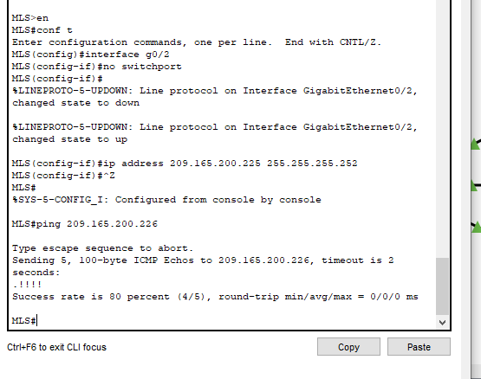

# Part 2

# Step 1

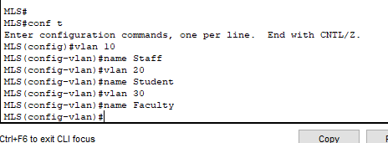

# Step 2

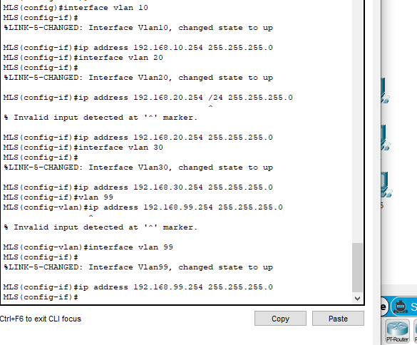

# Step 3

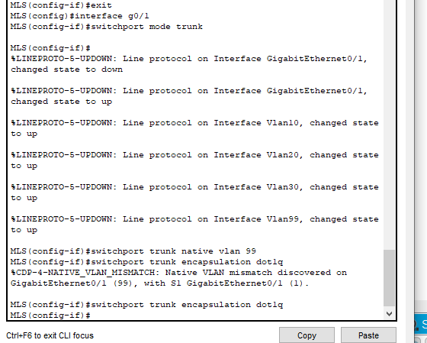

# Step 4

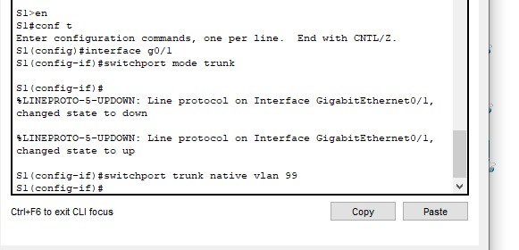

# Step 5

Use the show ip route command. Are there any active routes?

**No there are no routes found**.

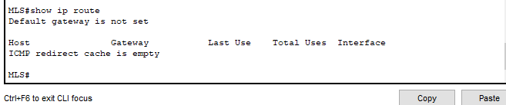

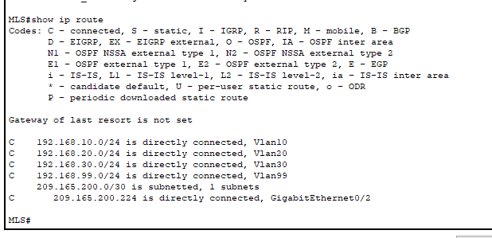

# Step 6

a. From PC0, ping PC3 or MLS to verify connectivity within VLAN 10.

**Ping successful from PC0 to PC3.**

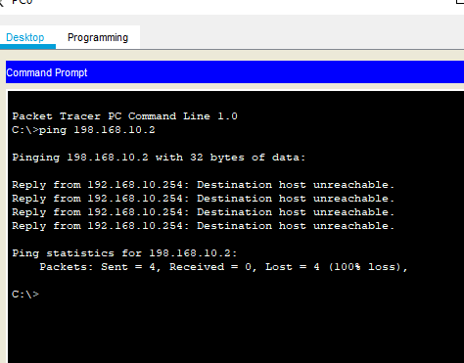

b. From PC1, ping PC4 or MLS to verify connectivity within VLAN 20.

**SUCCESSFUL**

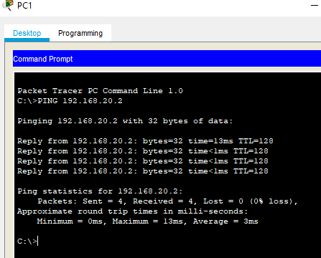

c. From PC2, ping PC5 or MLS to verify connectivity within VLAN 30.

**SUCCESSFUL**

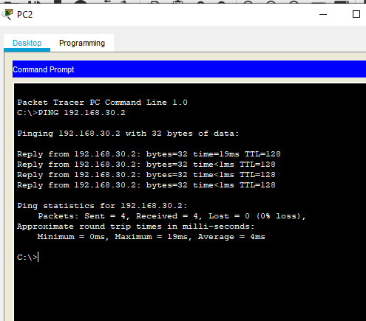

d. From S1, ping S2, S3, or MLS to verify connectivity with VLAN 99.

**Successful**

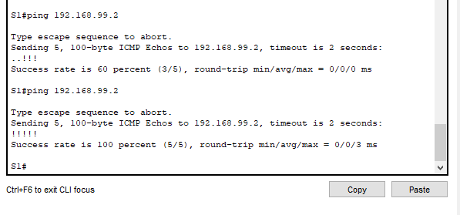

e. To verify inter-VLAN routing, ping devices outside the sender’s VLAN.

**Successful**



f. From any device, ping this address inside Cloud, 209.165.200.226.

**Successful**

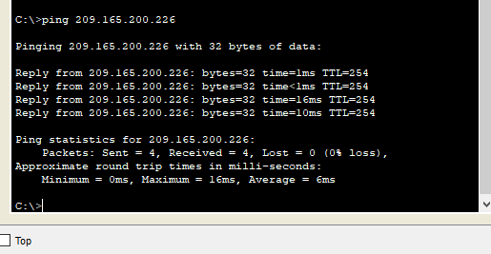

# Part 3

# Step 1

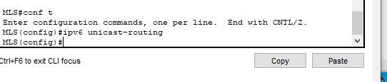

# Step 2

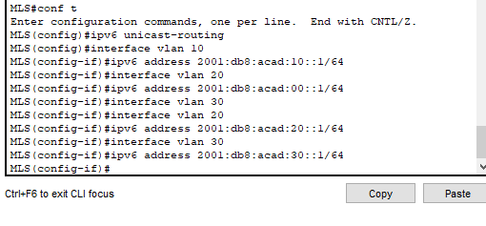

# Step 3

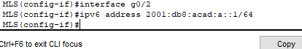

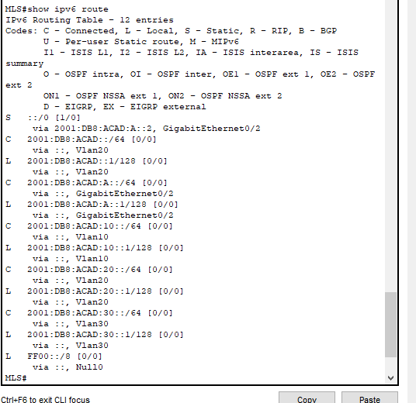

# Step 4

a. From PC3, ping MLS to verify connectivity within VLAN 10.

**Successful**

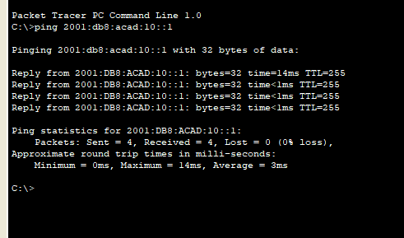

b. From PC4, ping MLS to verify connectivity within VLAN 20.

**Successful**

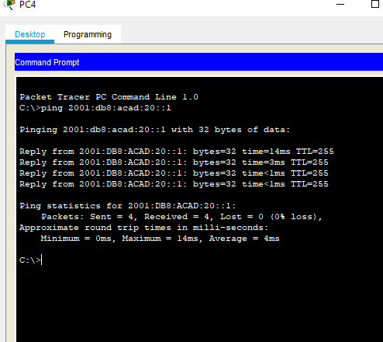

c. From PC5, ping MLS to verify connectivity within VLAN 30.

**Successful**

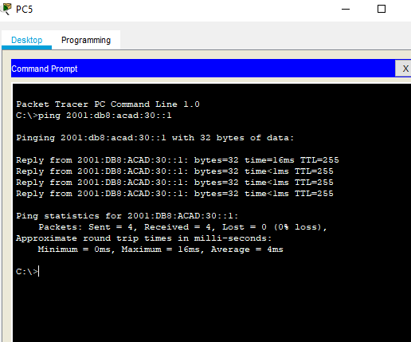

d. To verify inter-VLAN routing, ping between devices PC3, PC4, and PC5.

**Successful**

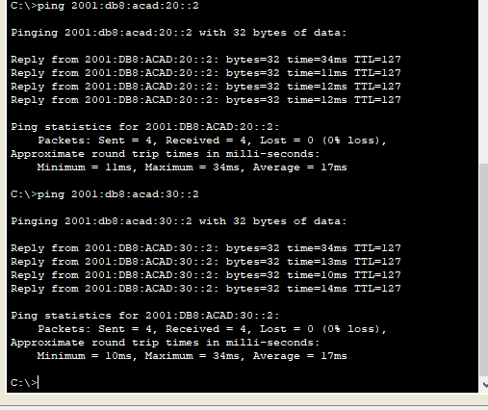

e. From PC3 ping the address inside Cloud, 2001:db8:acad:a::2.

**Successful**

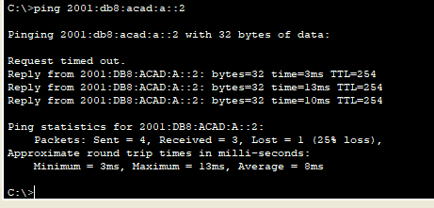

# Completion status

